Enter hospital via the 15, 45 or 75 Francis Street Entrance.
(Directions via car/public transportation located below)
BWH Asthma Research Center (ARC) is located in the Surgery Building Floor 1, Mid-Campus Suite 155.
Step-by-step directions to navigate Brigham available by using the BWH Wayfinding Website: enter your starting point and search for Asthma Research Center.

Enter Hospital at 75 Francis Street (Google Map Directions to 75 Francis Street Boston, MA 02115)
Enter lobby and go to right past the “M” elevators on your right and the escalator on your left towards the Elaine and Gerald Schuster lobby. Continue toward the glass bridge and staircase with the public restrooms on your right. After the restroom entrance take a right down hallway marked “Connors Center/Lower Pike” and follow signs “Conner’s Center for Women’s Health” Continue past the Conner’s Center entrance on your left, up the small set of stairs directly ahead of you, passing under the overhead sign that says, “Lower Pike Staff Corridor”. The “G” elevator will come up on your left and directly after elevator is a hallway identified by the overhead sign reading “Police/Security & Parking/Photo ID Office.” Take a left down hallway, pass a series of orange and blue lockers on your right and continue to the end of hallway. The Asthma Research Center will be on your right. Ring the bell on the wall and someone will be with you shortly.

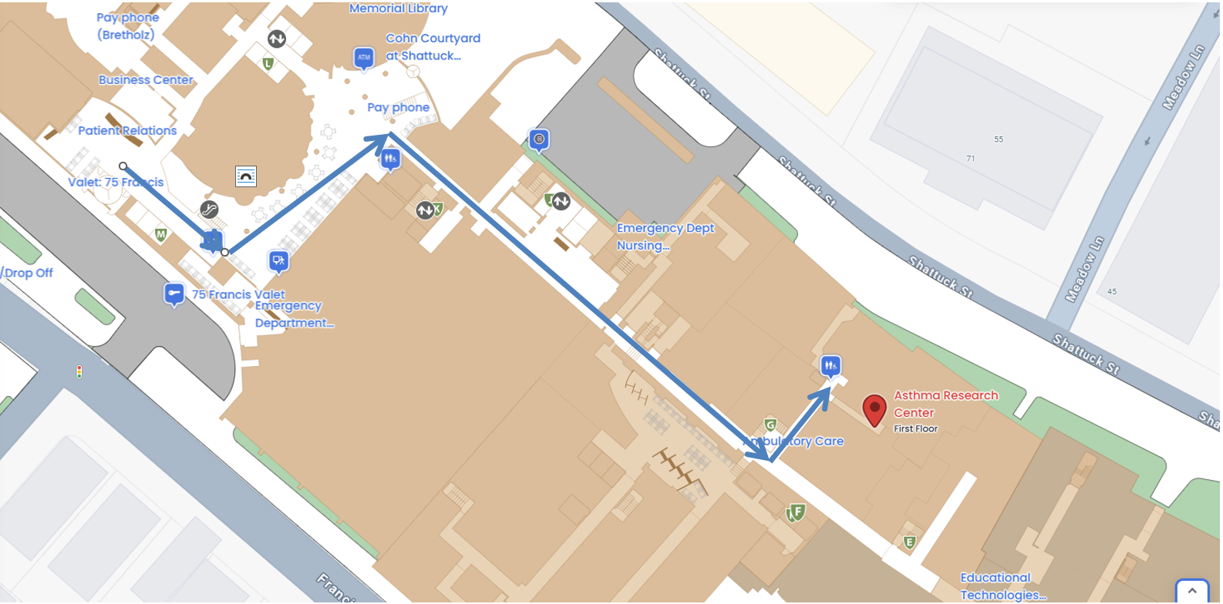

Enter Hospital at 15 Francis Street
At the 15 Francis Street entrance, enter the lobby and at security desk take a left down the hallway, following the signs for the “Pike.” Elevators on this hallway are labeled by letter on overhead signs, pass the “C-F” elevators, and proceed to the “G” elevator on your right, directly after the “Plastic Surgery” department. Elevator “G” is marked on the sign above and on elevator door. Take the “G” elevator down one floor. Turn left as you exit the elevator and take an immediate left down the first hallway identified by the overhead sign reading “Police/Security &Parking/Photo ID Office.” Pass a series of orange and blue lockers on your right and continue to the end of hallway. The Asthma Research Center will be on your right. Ring the bell on the wall and someone will be with you shortly.

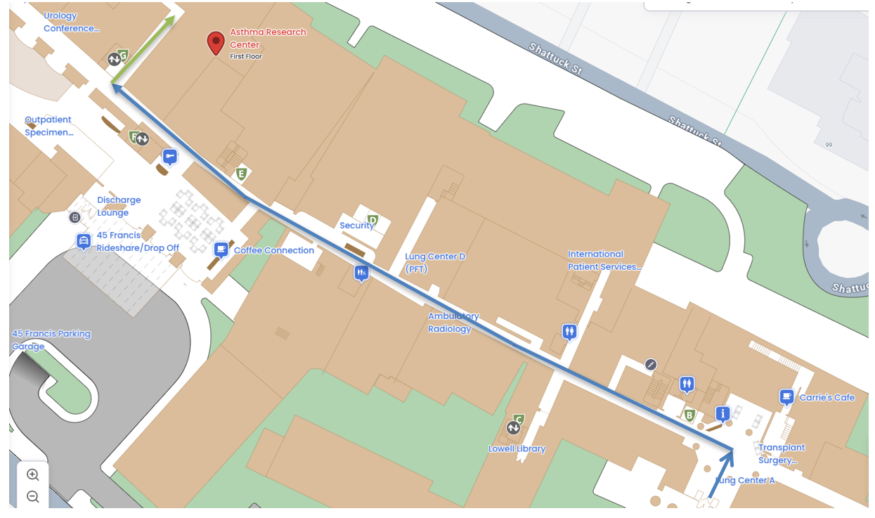

Enter Hospital at 45 Francis Street (Google Map Directions to 45 Francis Street Boston, MA 02115)
When you enter lobby, the “Brigham and Women’s Hospital Information Desk” and a parking cashier desk, will be located on either side of the parking elevators. Proceed past the “Brigham and Women’s Hospital Information Desk” to the doorway marked with arrows to “75 Francis St Lobby,” “Shapiro & 60 Fenwood Rd,” and “15 Francis St Lobby.” Proceed straight through the doorway and to the “G” elevator directly in front of you. Elevator “G” is marked on the sign above and on elevator door. Take the “G” elevator down one floor. Turn left as you exit the elevator and take an immediate left down the first hallway identified by the overhead sign reading “Police/Security &Parking/Photo ID Office.” Pass a series of orange and blue lockers on your right and continue to the end of hallway. The Asthma Research Center will be on your right. Ring the bell on the wall and someone will be with you shortly.

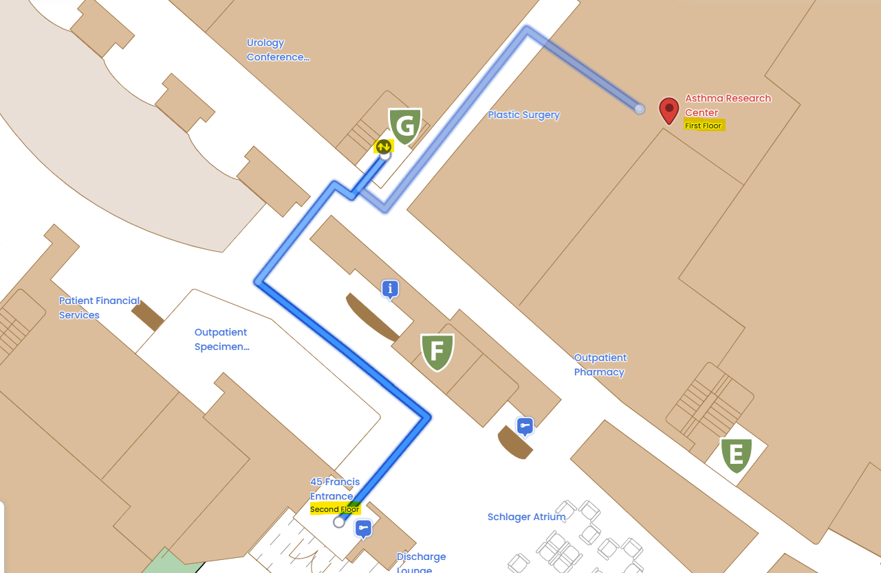

DIRECTIONS TO THE HOSPITAL BY AUTOMOBILE
From the North:
Head west on Storrow Drive. Take the Fenway outbound 1-S exit (on the left). At the lights bear right onto Boylston Street. At the third set of lights bear left onto Brookline Ave. At the fourth set of lights on Brookline Avenue, turn left onto Francis Street.
From the West:
Head east on the Mass turnpike (Rt. 90). Take Route 128 south for approximately one mile. Take Route 9 east for six miles. Bear left onto Brookline Avenue – at the Brook House Apartments, at the fourth set of lights, turn right onto Francis Street.

Or
Continue east on Mass. Turnpike. Take the Huntington Avenue/Copley Square exit. Follow Huntington Avenue west for three miles. At the Brigham Circle, take a right onto Francis Street.
From the South:
Head North on Route 3 (Southeast Expressway). Take Mass Ave/Roxbury exit. At the end of the ramp, cross Mass Ave. onto Melnea Cass Blvd. At the end of Melnea Cass Blvd., turn left onto Tremont Street, then your first right onto Ruggles Street. At the intersection of Ruggles Street and Huntington Ave, turn left onto Huntington Avenue and then right at Brigham Circle to Francis Street.

Valet parking is for patient use only and is available at both of the hospital’s Francis Street entrances, 45 Francis Street(Google Maps) and 75 Francis Street(Google Maps).

Self-parking is available at the 80 Francis Street Garage, located at the corner of Brookline Avenue and Francis Street. Patients may also self-park at the 45 Francis Street Garage located below the hospital entrance at 45 Francis Street.

For additional information about parking and navigating Brigham and Women’s Hospital, please visit https://www.brighamandwomens.org/about-bwh/locations/boston-main-campus-self-parking-and-valet
------------------------------------------------------------------------------------------------------------
DIRECTIONS TO THE HOSPITAL BY PUBLIC TRANSPORTATION
VIA the Green Line “E” Heath Street Trolley: Take train to Brigham Circle. The 15 Francis Street entrance (one entrance to Brigham and Women’s Hospital) is on the corner of Huntington Ave and Francis Street.

VIA # 39 Bus: Take bus to Brigham Circle (Tremont/Francis Street Stop). The 15 Francis Street entrance is on the corner of Huntington Ave and Francis Street

